Taxing powers of the barangay

(Other Sources of Revenue in the Barangay)

Other Sources of Revenue

- I. Community Tax Certificates

- II. Clearances and Certifications

- III. Real Property Taxes

- IV. Taxes, fees and charges

COMMUNITY / RESIDENCE TAX

- It is being collected by the City Treasurer who can deputize the Barangay Treasurer for the collection.

- Class “A” CTC usually refers to the Basic Tax/Unemployed = P5.00

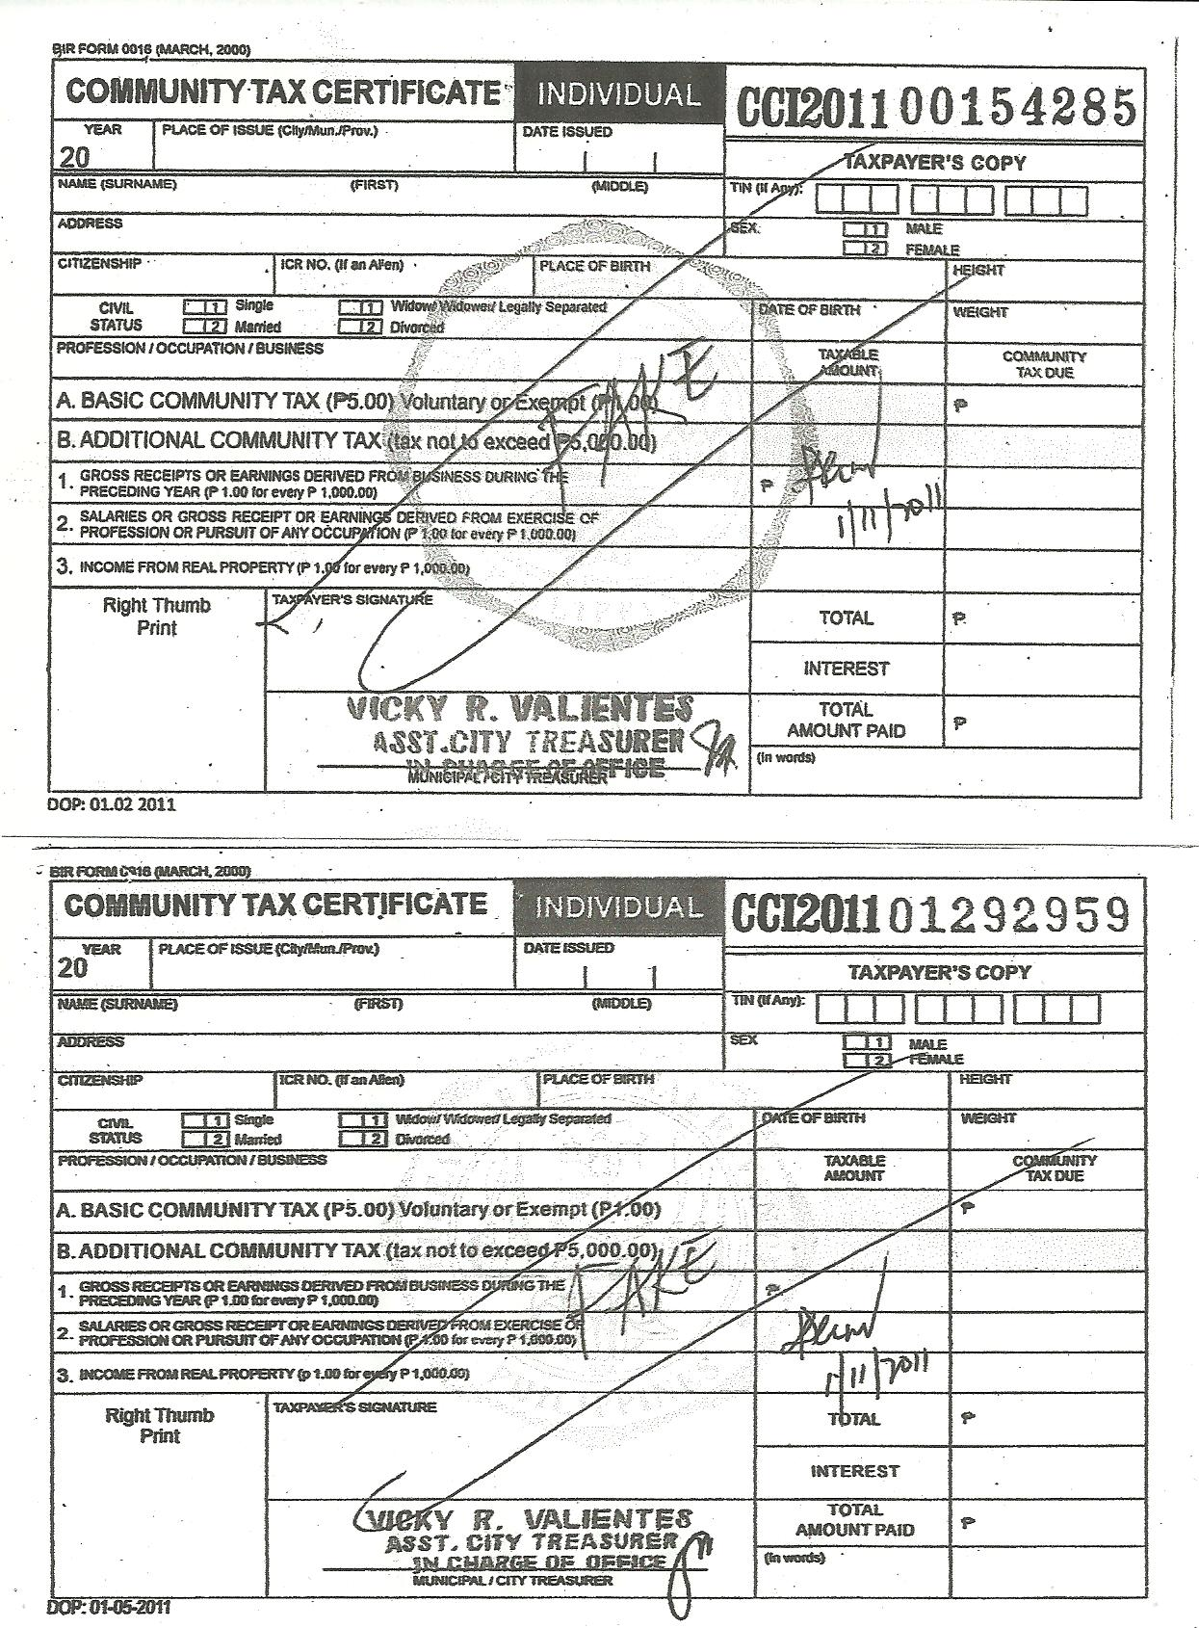

- Basic Tax of P5.00 (shall be collected up to February 28, 2011)

- In case of delayed payment, an interest of 2% per month shall be charged or P.10

- E.g. payment made on May 2011, computation
shall be: P5.00 x 2% x 5 mos. = P5.50

Revenue from CTC

- 5% - Cost of Printing
- 95% - shall be divided equally between the City and the Barangay (at 47.5% each)

- By issuing CTCs in your barangay:
(i) you bring public service to your constituents;
(ii) you prevent proliferation of fake CTCs;
(iii) you get additional funds for your barangay.

CLEARANCES & CERTIFICATIONS

- Before a city/municipality can issue a license or permit for any business or activity, a clearance must first be obtained from the barangay where such business or activity is located or conducted.

- It may also be a Certification of Good Moral Character, of being a bonafide resident, or of no-pending case, or even a Certificate of Indigency.

- For such clearance, the sangguniang barangay may impose a reasonable fee.

- The application for clearance shall be acted upon within 7 working days from the filing thereof.

- Use the SOR Form 19-A
- Cost of Printing = P126.50
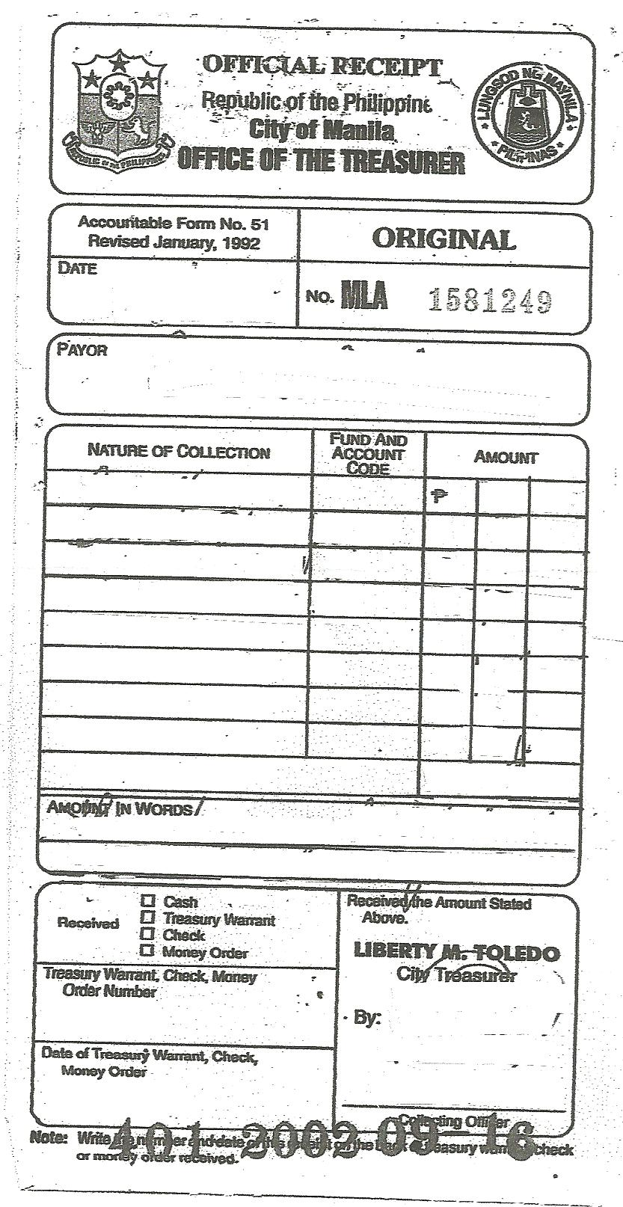

How to Obtain Accountable Forms

1. BOND – Bgy. Treasurers should apply at the
Bureau of Treasury
- OATH OF OFFICE or APPOINTMENT PAPERS
- IDENTIFICATION CARD

- Submit the following documents to the Accountable Forms Section, CTO together with the Recommendation from Atty. Buan

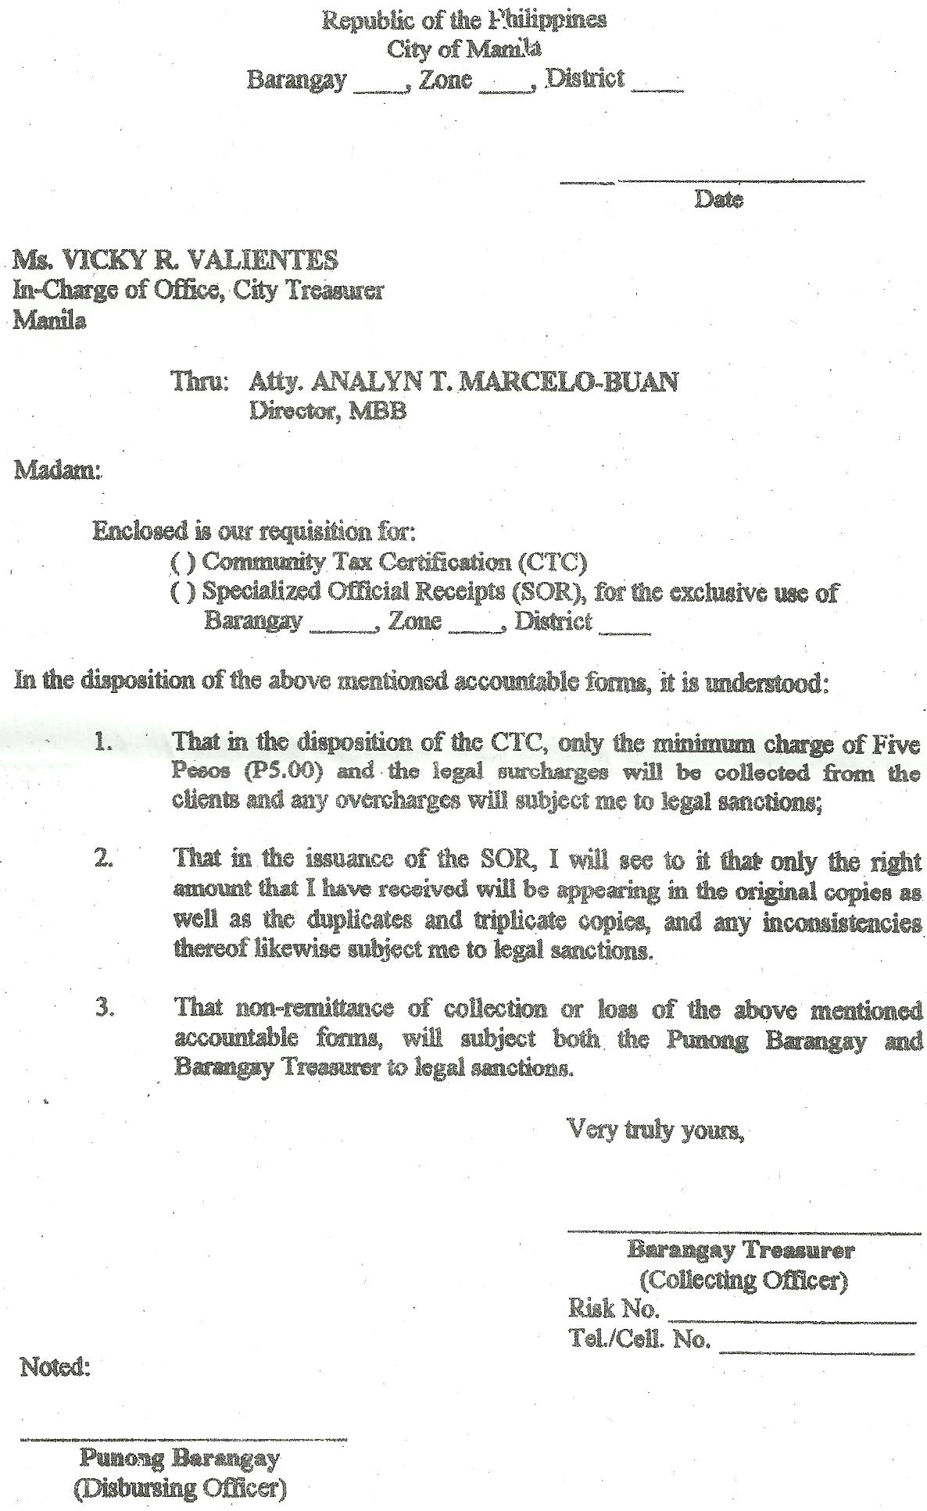

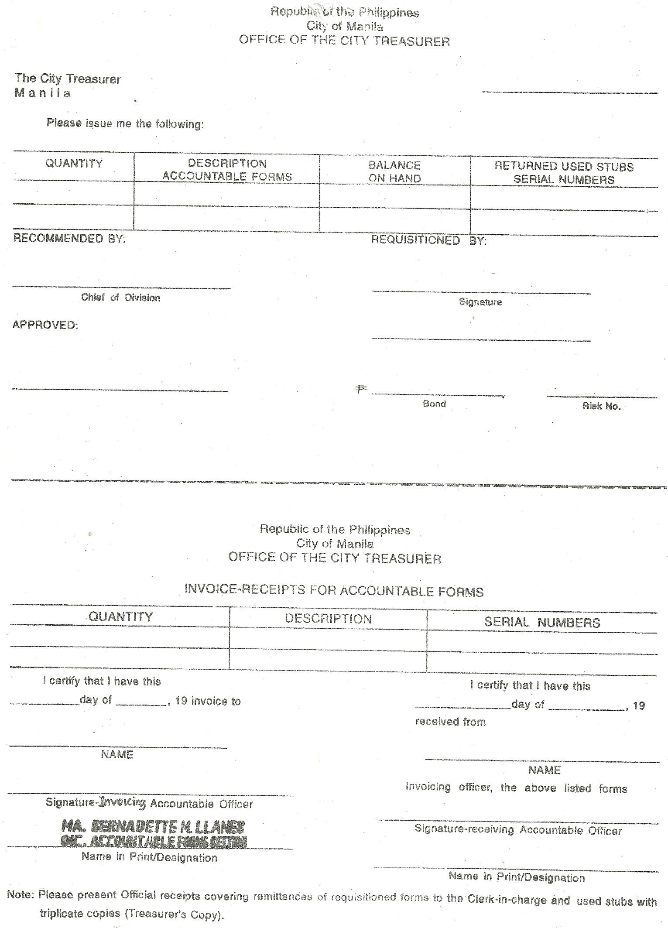

REAL PROPERTY TAX

- 70% of the collection – GENERAL FUND
- 30% of the collection – TRUST FUND
to be divided as follows:

15% shall be a common barangay share;
15% shall be for the barangay where the property is located

Taxes, Fees & Charges

(Under Sec. 152 of the Local Government Code)

- Taxes – On stores or retailers with fixed business establishment with gross sales or receipts for the preceding calendar year of P50,000 or less, in case of cities, at a rate of not exceeding 1% on such gross sales/receipt.
e.g. P50,000/12 mos = P4,166 / 30 days
=P138/day

- Service fees or charges – Barangay may collect reasonable fees or charges for services rendered in connection with the regulation or the use of barangay-owned properties or service facilities such as palay, copra, or tobacco dryers.

(c) Other fees and charges – Barangay may levy reasonable fees and charges on:
(1) commercial breeding of fighting cocks, cockfights and cockpits;
(2) places of recreation which charge admission fees; and
(3) billboards, signboards, neon signs, and outdoor advertisements.

REMINDER!!!

- There should be a valid enabling Ordinance before the Barangay can collect fees and charges.
- When you collect fees and charges, use the SOR (Official Receipt issued by the City Treasurers Office)

